MEDIAN ACCESS DESIGN CRITIERIA

April 3, 2018

TABLE OF CONTENTS

SECTION PAGE

1.0 Intent of Median Access Design Criteria 1

2.0 Work Zone Speed 2

3.0 Pavement and Shoulder Width 2

4.0 Horizontal Curves 2

5.0 Grades 3

6.0 Lane Length 3

7.0 Traffic Control Devices 4

8.0 Pavement Marking 4

9.0 Signing 5

10.0 Restrictions 5

- INTENT OF MEDIAN ACCESS DESIGN CRITERIA

This project entails the widening of I-26 from MM 85 to MM 101 with an approximate length of sixteen (16) miles. The project includes adding one travel lane in each direction from MM 85 to MM 97 and two travel lanes in each direction from MM 97 to MM 101. Construction vehicle access will be allowed during day time operations without I-26 lane closure(s). The Resident Construction Engineer (RCE) has the right to remove the median access from operation at any time the RCE deems necessary. Design criteria were derived primarily from:

- 2003 SCDOT Highway Design Manual with updates effective as of the Final RFP release date and supplemented with AASHTO A Policy on Geometric Design of Highways and Streets, 2001
- AASHTO “A Policy on Geometric Design of Highways and Streets”, 2004
- AASHTO “A Policy on Design Standards Interstate Systems”, 2005
- Procedure and Guidelines for Work Zone Traffic Control Design
- NCHRP Report 505 “Review of Truck Characteristics as Factors in Roadway Design”
- NDOR Research Project Number SPR-P1(06) P582 Transportation Research Studies “Acceleration Ramps along High Operating Speed Roadways”

- WORK ZONE SPEED

  - INTERSTATE

I-26 (Design) 70 mph
I-26 (Posted) 70 mph

- PAVEMENT AND SHOULDER WIDTH

  - INTERSTATE

Auxiliary Lanes 12 ft

4.0 HORIZONTAL CURVES

4.1 INTERSTATE

I-26 Match existing
Superelevation (I-26) Match existing
5.0 GRADES

5.1 INTERSTATE

Allowable Maximum +/- 4% (with appropriate factor adjustment from Figure 16.4J SCDOT HDM for lane length)

6.0 LANE LENGTH

6.1 AUXILIARY LANE

Assume “STOP” as design speed of first governing control (deceleration) and entrance curve design speed (acceleration) of and 70 MPH as “Hwy Design Speed”. Use NCHRP Report 505 for a 180 lb/hp truck for base length of 3060 ft for minimum acceleration length.

6.1.1 Acceleration Lane - Use NCHRP Report 505 for a 180 lb/hp truck for base length of 3060 ft.

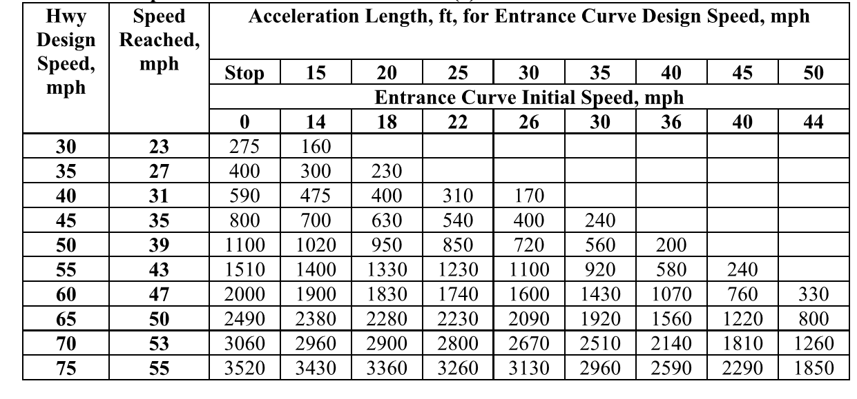
6.1.2 Deceleration Lane – Use Figure 16.4C SCDOT HDM. Assume 70 MPH design speed to a “STOP” condition.

6.2 TAPER LENGTH

Interstate 300’
7.0 TRAFFIC CONTROL DEVICES

7.1 PERMANENT

Portable concrete barriers (PCB) shall be place parallel the entire distance of the auxiliary lane and taper at the edge of the paved shoulder. PCB shall overlap a minimum of 20’ at openings.

7.2 TEMPORARY

When auxiliary lanes and tapers are not in use, drums shall be place per standard drawing 601-010-00 in the unused lanes.

7.3 END TREATMENT

A Portable Terminal Impact Attenuator for the appropriate design speed shall be uses at all exposed end of PCB per Std Dwg 605-425-00.

8.0 PAVEMENT MARKING

8.1 LANE LINE

Between Travel Lanes 10’ x 30’ skip
Between Travel Lane & Shoulder 6 in Solid Yellow
Lane Lines
In Auxiliary Lane 24 in Yellow Diagonals
at 20’ Spacing

8.2 RAISED PAVEMENT MARKERS

(Between Travel Lane and Auxiliary Lane) two yellow 4” x 4” Mono-Directional side by side at 20’ intervals along ingress/egress areas

9.0 SIGNING

Signing shall follow MUTCD requirements and be placed on both the outside and inside lanes. Signing shall differentiate between Exiting and Entering vehicles from the left lane at the 0’, 500’, 1000’ and 2000’ intervals from the beginning of the travel lane exit taper or travel lane entrance merge point (end of temporary barrier wall). When auxiliary lane is closed the signs shall be bagged. Final signing plans shall be submitted to the SCDOT for approval prior to implementation. See attached Figure 1 for a detailed drawing of the intended median access design.

10.0 RESTRICTIONS

10.1 TIME

10.1.1 EASTBOUND LANE

6AM-10AM & 4PM-8PM Mon-Fri
No restriction Sat & Sun

10.1.2 WESTBOUND LANE

7AM-10AM & 4PM-8PM Mon-Fri
No restriction Sat & Sun

10.2 SPACING OF AUXILIARY LANES 2 MI

10.3 WEAVE LANE

A weave lane is not permitted. This is when an acceleration and deceleration lane is directly upstream or downstream of one another and uses the same auxiliary lane.

10.4 SPACING TO INTERCHANGES

10.4.1 Ingress Median Access Point

Any part of the ingress median access auxiliary lane and taper is prohibited 1000’ prior to any interchange exit ramp taper to 2500’ downstream of any interchange entrance ramp taper.

10.4.2 Egress Median Access Point

Any part of the egress median access auxiliary lane and taper is prohibited 2500’ prior to any interchange exit ramp taper to 2000’ downstream of any interchange entrance ramp taper.

