RD. / RTE. NO: |  | RD. / RTE. NAME: |  |  | PROJECT ID:
COUNTY: |  | PROJECT DESCR.
SUBMITTAL TYPE: |  | SUBMITTED BY: |  | RPG/DISTRICT/  CONSULTANT:
QA PERFORMED BY: |  | PROJECT TYPE: |  |  | DATE:

95% BRIDGE PLANS QUALITY ASSURANCE CHECKLIST
Notes to Reviewer: Bridge Plans shall be considered complete final plans by the designer and a thorough formal Quality Control (QC) / Quality Assurance (QA) review shall be performed by the Engineer of Record prior to submittal to the SCDOT Structural Design Support Office. Failure to provide completed plans with proper level of review by the Engineer of Record (EOR) will be cause rejection by SCDOT and submittal will be returned for proper plans preparation. Design review comments from previous plans submittals shall be verified and addressed on the plans by the EOR prior to comment responses returned to SCDOT along with updated Bridge Plans.
- Where SCDOT Drawings are referenced, the latest revision as shown on the SCDOT website at the time of design shall be used
- All project sheets revision block shall be updated with project ID, designers’ initials, and date

The list below is intended to be a select list of standard items that would aid a review performed by the Structural Design Support Quality Assurance Office. The list is not intended to be a comprehensive QA nor QC list and not every item on the list would be applicable or verified on every project. Plan submittals meeting all items in the list below do not relieve the Engineer of Record of the responsibility to design the structure and provide bridge plans in accordance with applicable design criteria. Plans that are noted as not being prepared per all applicable design criteria required for SCDOT projects will be cause for rejection and submittal will be returned for proper plans preparation.

A comprehensive list of SCDOT Design References is available on the SCDOT website:
https://www.scdot.org/business/design-quality.aspx

- If there are special provisions as part of this project, verify it’s on file
☐ Yes ☐ No ☐ N/A
- If a design variance required for any part of the project, verify it’s on file
☐ Yes ☐ No ☐ N/A
- Have Load Ratings for all applicable structures been submitted for review by SCDOT Bridge Maintenance Office?
☐ Yes ☐ No ☐ N/A

95% Bridge Plans Sheets
Title Sheet BDM 6.3.1
Summary of Estimated Quantities BDM 6.3.2
General Notes BDM 6.3.3
General Details BDM 6.3.3
Reinforcing Bending Details BDM 6.3.4
Roadway Typical Section BDM 6.3.5
Roadway Plan and Profile BDM 6.3.6
Stages of Construction BDM 6.3.7
Bridge Plan and Profile BDM 6.3.8
Boring Logs BDM 6.3.9
Foundation Layout BDM 6.3.10
Bent Sheets BDM 6.3.11
Prestressed Concrete Pile Sheet BDM 6.3.12
Superstructure Plan BDM 6.3.13
Framing Plan BDM 6.3.14.2
Prestressed Concrete Beam Details BDM 6.3.14.3
Structural Steel Details BDM 6.3.14.4
Girder Details BDM 6.3.14.5
Camber and Blocking Diagram BDM 6.3.14.6
Bearing Details BDM 6.3.14.7
Joint Details BDM 6.3.14.9
Top Slab Elevations BDM 6.3.14.10
Sidewalk and Railing Details BDM 6.3.14.11
Approach Slab BDM 6.3.15
Slope Protection Paving Details BDM 6.3.16
Drainage Details BDM 6.3.17
Utilities Details BDM 6.3.18
Existing Bridge Plans BDM 6.3.19

Title Sheet BDM Section 6.3.1
Reviewed during Preliminary Bridge Plans submittal. See Preliminary Bridge Plans Checklist

☐ Verify if all previous plan submittals e.g. preliminary plan comments are addressed and resolved for the entire project before proceeding with a QA review
☐ Verify Index of Sheets matches the title of each corresponding plan sheet
☐ Verify updated Asset ID number – MEMO DM0420 & LRDG
☐ Verify updated date stamp and level of completion note on the plan set submitted - BDM Section 6.3.1.9

Summary of Estimated Quantities BDM Section 6.3.2 & BDM Chapter 7
☐ Tabulation of Estimated Quantities provided - BDM Section 6.3.2.1
☐ Summary of Estimated Quantities provided - BDM Section 6.3.2.2

General Notes BDM Section 6.3.3, BDWG 700-03 (latest update)
☐ Verify project design per correct version of LRFD – BDWG 700-03
☐ Final Surface Finish selected – BDWG 700-03
☐ If widening project, verify if bridge meets the same seismic criteria as existing – MEMO DM0115
Seismic Design Criteria SDS Version 2.0 July 2008
☐ Verify seismic data:
- Verify seismic Operational Classification (OC) - SDS Table 3.1
- Verify Seismic Design Category (SDC) - SDS Table 3.5
- Verify analysis method - BDWG 700-03.01 and SDS Section 6.1
- Verify ADRS Data Tables have been completed - BDWG 700-03.01

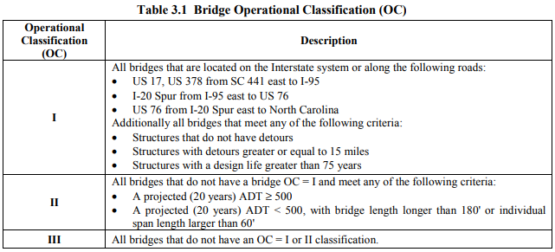
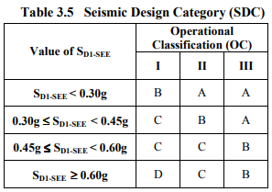
☐ Verify seismic data provided for Low Volume Bridges based on project location relative to Route 1, if applicable – BDWG 700-03, BDWG 700-03.01

General Notes & Details for Flat Slabs BDM Section 6.3.3, BDWG 700-04, 700-04.01 (latest update)
☐ Verify project design per correct version of LRFD – BDWG 700-04, BDWG 700-04.01
☐ Final Surface Finish selected – BDWG 700-04, BDWG 700-04.01
☐ Adhesively Bonded Dowel Detail provided (if applicable) shown with embedment dimensions provided and notes modified as appropriate - BDWG 700-04.01, MEMO DM0408

Seismic Design Criteria SDS Version 2.0 July 2008
☐ Verify seismic data:
- Verify seismic Operational Classification (OC) - SDS Table 3.1
- Verify Seismic Design Category (SDC) - SDS Table 3.5
- Verify analysis method - BDWG 700-03.01 and SDS Section 6.1
- Verify ADRS Data Tables have been completed - BDWG 700-03.01
☐ Verify seismic data provided for Low Volume Bridges based on project location relative to Route 1, if applicable – BDWG 700-03, BDWG 700-03.01

General Details BDM Section 6.3.3, BDWG 700-05, 700-05.01 (latest update)
☐ Anchor Bolt dimensions included - BDWG 700-05, BDM Section 21.2.1.7 and BDM Figure 21.2-2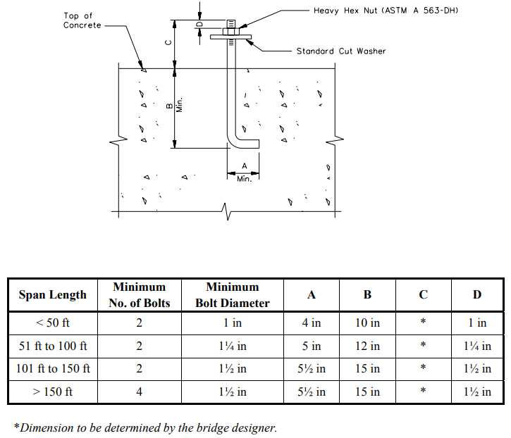
☐ Adhesively Bonded Dowel Detail provided (if applicable) shown with embedment dimensions provided and notes modified as appropriate - BDWG 700-05.01, MEMO DM0408
☐ Correct drain detailed included – BDWG 700-05, BDWG 700-05.01
- Verify if scuppers with grates are provided if the bridge has a sidewalk BDM Section 18.2.5.1
- Verify 6” min. diameter scuppers for inlets on all bridges - BDM Section 18.2.5.1
- Verify 8” min. diameter, fiberglass drainage pipe for bridges with closed drainage- BDM Section 18.3
☐ Structural Steel details provided (Structural Steel Superstructure only) - BDWG 700-05
☐ Welded Stud Detail dimensions provided, and weld sizes match the plans (Structural Steel Superstructure only) - BDWG 700-05
Miscellaneous Details Sheet BDM Fig. 20.2-1, BDWG 700-Misc
☐ Pipe Underdrain Detail and Pipe Outlet Detail included for prestressed beam and structural steel end spans - BDM Section 20.2.3 and BDWG 700-MISC.02

Reinforcing Bending Details SCDOT BDM Section 6.3.4 BDWG 703-01, 703-01.01 (latest update)

Roadway Typical Section - labeled “For Information Only” BDM Section 6.3.5
Reviewed by Roadway Design Support
☐ Verify if Typical Roadway Section provided matches the approaches on both sides of the bridge shown on Bride Plan and Profile sheet
☐ Verifytotal travelway width and shoulders match approaches on both sides of the bridge - BDM Figure12.6-1

Roadway Plan & Profile -labeled “For Information Only” BDM Section 6.3.6
Reviewed by Roadway Design Support
☐ Verify roadway plan and profile information provided matches Bridge Plan and Profile sheet
☐ Verify bridge end drainage shown consistent with Bridge Plan and Profile sheet
☐ Applicable thrie-beam connector shown and labeled
☐ Verify if vertical curve data shown is consistent with Bridge Plan and Profile sheet
☐ Verify Hydrology data shown is consistent with Bridge Plan and Profile sheet

Stages of Construction BDM Section 6.3.7
☐ Stages of Construction drawings and notes provided for each stage of construction – BDM Section 6.3.7
Reviewed by Bridge Construction and Work Zone Traffic Control

Bridge Plan & Profile
Bridge Plan & Profile should be complete at Preliminary Plans submittal with a few exceptions noted below. Structural Design Support shall be notified by the submitter if significant additions and changes are made between Preliminary and 95% Bridge Plan submittals.
☐ Verify all items listed in the Preliminary Bridge Plans Checklist have been resolved
☐ Scour Profile provided (if applicable) – BDM Section 6.3.8.1
☐ Soil Borings plotted with stations and offsets from construction centerline noted – BDM Section 6.3.8.1
☐ Verify roadways passing under the structure minimum horizontal and vertical clearances are met - BDM Section 12.6 & BDM Figure 12.6-2, Figure 12.6-8, Figure 12.6-9
- Minimum horizontal clearance = 30 ft. from edge of travel way- BDM Section 12.6
- Minimum vertical clearance per Figure 12.6-2 - BDM Section 12.6
- Verify of bents within 30 feet from edge of travel lane design for collision load or follow requirements below - MEMO DM0213
  - A minimum number of columns = 3; column has solid reinforced concrete cross section with minimum diameter = 3ft. and maximum column spacing = 20 ft. OR
  - Solid reinforced concrete pier walls having a minimum thickness of 2.5 ft. and a length of 20.0 ft; solid, reinforced concrete single columns having a minimum of 4.0 ft. by 12.5 ft. dimensions; or any other solid reinforced concrete sections having an minimum cross sectional area of 50 ft2 and a minimum thickness of 2.5 ft.

Railroad Crossings:
☐ Roadways and railroads passing under the structure – verify minimum horizontal and vertical clearances are met - BDM Section 12.6 & BDM Figure 12.6-8, Figure 12.6-9 and Section 22
- Standard horizontal clearance from the centerline of the track to face of pier or abutment = 25 ft. - BDM Section 22.2.3.2, MEMO 0307
- Minimum distance from footing = 15.0 ft. from the centerline of the track - BDM Section 22.2.3.2
- Minimum vertical clearance from top of rail = 23 ft. – BDM Section 22.2.3.2
- Maximum vertical clearance from top of rail =23.4 ft. – BDM Section 22.2.3.2
- Minimum distance between track centers = 15 ft.
- Minimum clearances on curved railroad track - BDM Section 22 as listed below:
☐ Clearances on curved railroad track- the lateral clearances on each side of the track centerline -increased
1.5 in. per degree of curvature on the railroad alignment as per BDM Figure 22.2-4. If superelevated track clearances on the inside of the curve increased by 3½ in. for each inch of elevation differential between the inside and outside edges of the superelevated section - BDM Section 22.2.3.2
☐ Verify if bents supporting bridges over railways are within a clear distance of 25.0 ft. or less from the centerline of a railroad track - BDM Section 22.2.3.5
  - Bents shall be of heavy construction or protected by a reinforced concrete crash wall to limit damage by the redirection and deflection of railroad equipment - BDM Section 22.2.3.5
  - Single-Column Bents: Crashwalls for single-column bents = minimum 2.5 ft. thick and extend a minimum of 10.0 ft. above the top of high rail. Wall to extend a minimum of 6.0 ft. beyond the column on each side in the direction parallel to the track
  - Multiple-Column Bents: Verify columns connected with a wall of the same thickness as the columns or 2.5 ft., whichever is greater. The wall to extend a minimum of 2.5 ft. beyond the end of outside columns in a direction parallel to the track and also to extend at least 4 ft. below the lowest surrounding grade
  - Reinforcing steel is adequately anchor the crashwalls to the column with footing provided
  - Heavy Constructed bents - solid reinforced concrete bents with a minimum thickness of 2.5 ft. and a length of 20.0 ft.; single-column bents of a minimum of 4.0 ft. by 12.5 ft. dimensions; or any other solid bent sections with equivalent cross sections and a minimum of 2.5 ft. thickness.
☐ Interior bents within 25 feet to 50 feet of CL of railroad tracks - MEMO DM0213
  - A minimum number of columns = 3; column has solid reinforced concrete cross section with minimum diameter = 3ft. and maximum column spacing = 20 ft. OR
  - Solid reinforced concrete pier walls having a minimum thickness of 2.5 ft. and a length of 20.0 ft; solid, reinforced concrete single columns having a minimum of 4.0 ft. by 12.5 ft. dimensions; or any other solid reinforced concrete sections having an minimum cross sectional area of 50 ft2 and a minimum thickness of 2.5 ft.
☐ ROW limits for railroads shown
☐ Verify temporary railroad construction clearances - BDM Section 22.2.3.2
- Minimum noted for tangent tracks from the centerline of track = 13.0 ft.
- Minimum noted for curved tracks = 14 ft. from the centerline of track
- Minimum temporary vertical construction clearance above the top of high rail =22.0 ft.
- Verify any notes for request to increase temporary clearances by the railroad company issued after review of the preliminary plans - BDM Section 22.2.3.2
☐ Verify all utilities that may interfere with bridge construction are relocated or removed
☐ Deck drains discharge outside of railroad right-of-way - BDM Section 22.2.8
☐ For bridge widening, comply with BDM Chapter 23

Boring Logs BDM Section 6.3.9
Reviewed by Geotechnical Design Support

Foundation Layout BDM Section 6.3.10
☐ Verify foundation design conflicts are avoided, or if any known conflicts exists it’s clearly noted
☐ Verify dimensions are provided to determine approximate distances between proposed and existing foundations – BDM Section 6.3.10
☐ Verify there are no conflicts between proposed foundations/embankment and utilities. Conflicts between proposed foundations/embankment with abandoned utilities shall be shown resolved to avoid issues with foundation installation
☐ Verify foundation size and dimensions are consistent with all other plans sheets

Long Chord Layout (Bridges on Horizontal Curves)
☐ Verify Long Chord Layout provided showing skew angles and offsets for curves at critical points – BDM Section 6.3.10
Can be included with Foundation Layout if space allows of sheet for clear detailing

Geotechnical Notes
☐ Geotechnical notes and parameters provided – BDM Section 6.3.11.6
Reviewed by Geotechnical Design Support

End Bent: BDM Section 6.3.11
Plan View
☐ Dimensions - Overall Cap Width and Length
- Verify minimum cap width for pile bents - BDM 20.1.3.1 and MEMO DM0312
Type of Pile | Minimum Cap Width  (Single Row of Vertical Piles)
HP 12x53 | 2’-6”
HP 14x73 | 2’-8”
18” Sq. PSC | 3’-0”
20” Sq. PSC | 3’-4” (DM0312)
24” Sq. PSC | 4’-0” (DM0312)
  - Verify minimum cap width =diameter of column/shaft plus 3” on each side -BDM Section 20.1.3.1
  - Verify minimum bent caps overhang equivalent of 2 pile widths for (pile bents) - MEMO DM0312
  - Verify a construction joint provided If length exceeds 70 feet - BDM Section 20.1.4 and detailed per BDWG 700-05
  - Bent cap length - BDM Section 20.1.3.2
    - Verify minimum 9 in from the centerline of the anchor bolt to the end of the bent cap
    - Verify minimum 9 in from the edge or corner of the elastomeric bearing or masonry plate to the end of the bent cap
  - Cored slab units - BDM Figure 20.1-3
    - Verify bent cap detailed with a concrete lateral guide at the outside face of the exterior slab units
    - Verify 1½-in expansion joint material between the cored slab and lateral guide and, if approach slabs are detailed-End Bent Only
    - Verify 1½-in expansion joint material between the approach slab and wing wall
☐ Pavement rest = minimum 8” wide -SCDOT BDM Section 17.4.2.5 and 20.2.3.5 - End Bent Only
☐ Verify skew angle between bridge centerline and bearing and bent centerlines
☐ Beam Seats
  - Verify note to contractor to refer to bearing details sheet for additional details
  - Verify location, size, and applicable dimensions to the anchor bolts
  - Verify horizontal rebar size and spacing
  - Verify seat width and length dimensions
☐ Verify wing wall dimensions
☐ Verify joint filler material type and thickness

Elevation View
☐ Overall dimensions
  - Cap Depth
    - Verify minimum depth of 2’-6” for single row of piles and 3’-0” for double row of piles -BDM Figure 20.1-2
    - Verify minimum depth of 2’-8” for 18” square prestressed concrete pile bent, supporting slab superstructure - MEMO DM0312
    - For pile bents with piles larger than 18” square, verify if maximum pile embedment may increase the depth of pile caps for constructability and due to the effects of punching shear- MEMO DM0312

  - Verify basic dimensions from end of cap to exterior pile/shaft/column & distance from construction centerline to nearest piles/shafts/columns are consistent with other plans sheets
  - For skews greater than 20 degrees, verify a 3” minimum chamfer at acute corners - BDM Section 20.2.3.7 -End Bent Only
☐ Longitudinal reinforcement -BDM Section 20.1.6.1
  - Verify minimum reinforcement - BDM Figure 20.1-4
Cap Width | Min. Reinforcing Steel
<= 3’-0” | (4) #9 (29M)
3’-0” – 4’-0” | (5) #9 (29M)
4’-0” – 5’-0” | (6) #9 (29M)
5’-0” – 5’-8” | (7) #9 (29M)
  - Verify bars are not bundled
  - Verify no more than two layers of main reinforcing bars
  - Verify selected splice lengths are noted on plans per MEMO 0320 for appropriate Class splice and/or top bar placement
  - Verify selected development length at cap overhangs and footings noted on plans- MEMO0320
☐ Transverse reinforcement - BDM Section 20.1.6.2
- Verify selected stirrups spacing between supports are S-bar bend details with 135-degree seismic hook with hook extensions not less than the larger of 10 bar diameters or 6 in
  - Verify minimum bar size is #5 (16M)
  - Verify maximum spacing is 12”
  - Verify location of double stirrups required for cap widths of 4’-6” or greater. When double stirrups are used, verify minimum of four longitudinal bars between the overlapping stirrups are provided - BDM Figure 20.1-5
  - Verify 180° hook detailed with vertical reinforcing projecting from the cap - MEMO DM0206
☐ Verify if cap is sloped for superelevated roadways if build-up exceeds 12” on a level cap - BDM Section 20.1.7
☐ Verify top of caps slope between buildups transversely a minimum of 5% at expansion joints - AASHTO 2.5.2.1.2 and BDM Section 20.2.3
  - If beam seat elevation difference between any two adjacent beam seats is:
    - less than 3/16 in, verify the build-up is level and the lower elevation for both beam seats is used;
    - 3/16 in. to 1 in, use the lower elevation for both beam seats, verify if a booster plate is detailed with the bearing plate, and allow the contractor the option to combine the booster plate with the bearing plate; or
    - 1 in or greater, verify if a split-level build-up is detailed
☐ Verify if elevation at top of level cap, at top corners of a sloped cap and at construction centerline or at top of the buildups are noted.
☐ Table of elevations included if bent represents similar bents but different elevations
☐ Verify #4 (13M) U-shaped bars at 12” max spacing each way are detailed for cap build-ups taller than 4”- BDM Section 20.1.6.3. These reinforcing bars shall be properly developed into the bent cap
☐ Steel Piles - BDM Section 20.2.7.1 - End Bent Only
  - Verify type and size - HP 12x53, HP 14x73, HP 14x89, and HP 14x117
  - Verify the minimum embedment length - MEMO DM0209
  - Verify maximum pile spacing should be less than 10’-0” BDM Section 20.2.7.1
  - Verify minimum edge distance met – 9” -BDM Section 19.2.6.2
  - Verify minimum overhang distance met– 18” BDM Section 20.2.7.1
  - Verify minimum pile count is 4 piles - BDM Section 20.2.7.1
  - For integral end bents, verify all end bent piling shall be driven vertically, and only one row of piling is permitted BDM Section 20.2.7.2
  - Verify piles are minimum of 10 ft. in length - BDM Section 19.2.4
☐ Prestressed Concrete Piles
  - Verify sizes 18 in., 20 in., 24 in. square - BDM Section 19.2.3.3
  - Verify Steel Pile extensions W8x58, HP10x57, and HP 12x53
  - Verify distance from centerline exterior pile to end of cap > 2 times the pile width
  - Verify maximum pile spacing should be less than 10’-0” BDM Section 20.2.7.1
  - Verify center to center pile spacing is not less than the greater of 30 in. or 2 ½ times the pile diameter or width of pile – LRFD Article 10.7.1.2
  - Minimum overhang distance met – MEMO DM0312
  - Pile connection to cap should be an equivalent of 1.3 pile widths
  - Verify prestressed pile bent maximum span around 50 ft.

☐ Columns/Drilled Shafts
  - Verify diameter of column, drilled shaft, and/or rock socket is consistent with all other plans sheets
  - Verify maximum spacing range = 25’-0” BDM Section 20.3.3.3
  - Verify drilled shaft diameter measured from the outside of the construction casing
  - Verify construction joint shown at bottom of cap - BDM Section 20.3.2.3
- Verify construction joints at least 5 ft. above the water elevation expected during construction -MEMO DM0111
- Verify all shafts detailed with construction casing unless approved otherwise by the RPG Engineer. The portion of the shaft below the bottom of the casing, whether in soil or rock, shall be detailed with a diameter that is six inches smaller than the diameter of the construction casing -MEMO DM0111
☐ Staged Construction
  - Verify selected splices for longitudinal bars located in subsequent stage and conform to MEMO DM0320
  - For staged construction on large skews, verify that stirrups do not straddle construction joints
☐ Verify lateral guides are provided for cored slab structures at the outside of each exterior slab unit - BDM Figure 20.1-3
☐ Shear keys/retainers at expansion joints for SDC B, C, and D bridges - MEMO DM0115
  - Verify shear key skewed parallel to girders - BDM Section 20.1.9 & BDM Figure 20.1-6
  - Verify steel shear keys shown on each side of the girder and detailed by SDS Figure 9.3; SDS Section 9.2.3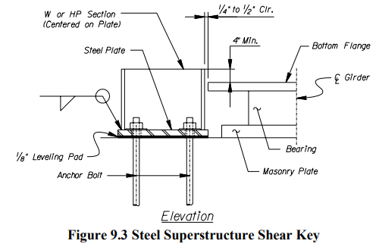
☐ Retainer blocks - SDS Section 9.4.3
- Verify retainer block placed on non-integral end bents when skew angle > 20 degrees
  - Verify retainer block poured monolithically with cap
  - Verify that SDS Figure 9.6 with minimum 2” concrete cover is detailed
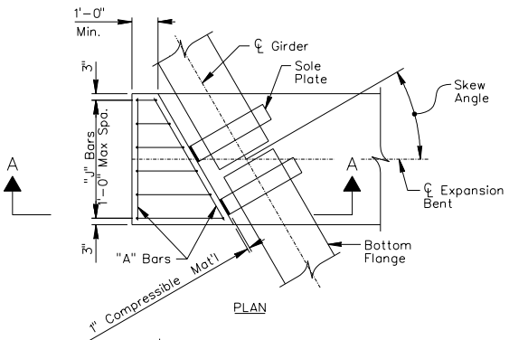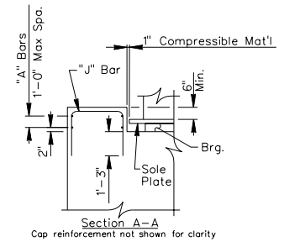
End Bent Details:
☐ Section through Cap
  - Verify non-integral bent caps used for flat slabs - BDM Section 12.3.2.2
    - Verify selected components are consistent with all other plan sheets
  - Free-standing end bents - BDM Section 20.2.6
    - Verify 12” minimum, constant backwall thickness
    - Verify construction joint detailed between top of bent cap and bottom of backwall
    - Verify level beam seats. The remaining exposed top surfaces - transversely sloped away from the fill face -- AASHTO 2.5.2.1.2 and BDM Section 20.2.3
- Verify expansion joint types at the pavement rest. Use a shear key for any horizontal construction joints
  - Integral end bents per BDM Section 20.2.4 and Semi-integral end bents per BDM Section 20.2.5
    - Verify end wall detailed full width of bent and cast with deck-Integral Bents Only
    - Verify integral end bent in BDM Section 20.2.4 detailed as a semi-integral end bent with exception of hinge or bond-breaker detailed between the bent cap and end wall
    - Verify selected concrete cover locations beyond edge of the girder at rear face of end wall is 4” minimum. This also applies to the pavement rest area
    - Bar inserts
      - Verify holes in webs of girders are spaced at 12” max
      - Verify holes and bars within end wall rebar cage shown
    - Deck Slab Bars: Verify L-shaped bars extending from end wall into top of slab at max 12” spacing
    - Verify there are no battered piles at integral end bents - BDM Section 20.2.7
- Verify parallel wing walls shown with semi-integral end bents - BDM Section 20.2.5
- Verify semi-integral end bents detailed with a horizontal construction joint permitted between
the bottom of slab fillet and the top of end wall
- Verify integral end bents, a horizontal construction joint detailed at the top of the bent cap
  - Verify hammerhead cap longitudinal reinforcement and limitations of length of cantilever (maximum 2 rows of reinforcing and no bundling of bars in cap) - BDM Section 20.3.4
  - Verify minimum support length of superstructure measured longitudinally to face of cap at expansion bents - SDS Section 9.1
    - SDC A and Single Span = 12”
    - SDC B and C = 14”
    - SDC D = 24”
  - Verify select areas of concrete typical clear cover - BDM Figure 15.3-2
    - Typically, 3” bottom cover, 2” side and top cover
  - Verify dowels protruding from the bent cap into the end wall are terminated with a standard 180-degree hook - MEMO DM0206
  - Verify top of the bent cap - minimum of 12 in above the surrounding grade (including if any rip rap allowed to be placed on top of earth berm). The bottom of the bent cap detailed a minimum of 12 in below the earthen berm -BDM Section 20.2.3. Verify the rip-rap thickness resting on top of earthen berm is accounted for when cap depth determined – RDWG 804-105-00
  - Verify vertical expansion joints detailed for cap lengths exceeding 90 ft. Verify the joint is waterproofed - BDM Section 20.2.3
  - For staged construction with large skews, verify that the stirrups do not straddle construction joints in both back wall and diaphragm
  - Verify construction joint between the end wall and the bent cap is waterproofed - BDM Section 20.2.3
☐ Verify steel HP Pile Anchorage Detail - BDM Section 19.2.6.3 and MEMO DM0209
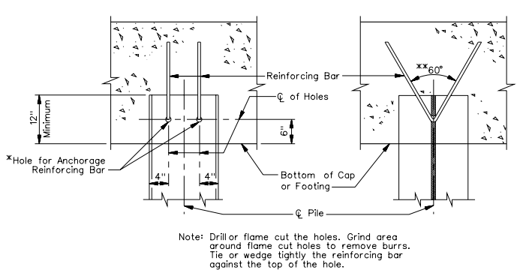
  - 2 V-shaped #6 (19M) bars developed past the bottom mat of reinforcement - BDM Figure 15.3-4
  - Minimum hole size = ¼” larger than bar diameter
  - Maximum hole size = 2 times the bar diameter
  - Minimum pile embedment – 12”
☐ Quantities Table
  - Verify class 4000 concrete - BDM Figure 15.2-1
  - Verify quantities table for each bent or typical bent are included on a Bent Sheet. - See BDM Figure 7.1-1 or the SCDOT Standard Specifications for a list of applicable quantities and rounding accuracy
  - Verify on projects requiring stage construction that quantities shall be broken down by stage – BDM 6.3.2
☐ Reinforcing steel schedule - BDM Section 6.3.11.5
  - Uncoated steel max length is 60 ft.
  - Galvanized steel max length is 40 ft.
  - #4 (M13) max length is 30 ft.
☐ Verify Beam Seat Detail
  - Verify #4 U-shaped bars at 12” max spacing each way for cap build-ups taller than 4” - BDM Section 20.1.6.3
  - Verify Buildup details match what is shown on the End Bent Elevation View
☐ For end bents with MSE walls located within 30 feet from edge of travel lane shall have provisions for redirecting or absorbing a collision load – MEMO DM0213
☐ Minimum distance of 3 ft. maintained on the fill side between inside face of MSE wall and face of piling
☐ Verify Guardrail post does not conflict with cap at barrier connection for the guardrail type specified if approach slab not used

Wing Wall Details
☐ Verify minimum thickness – 12” - BDM Section 20.2.8
☐ Verify parallel wing walls to the centerline of bridge for structures other than flat slabs and cored slabs - BDM Section 20.2.8. Verify parallel wing walls detailed with approach slab. Verify parallel walls not extended more than 10 ft. behind the rear face of the end bent unless auxiliary pile footing is used to support the wing wall
☐ Verify ¾” joint between wing wall and approach slab - BDM Figure 20.2-3
☐ Verify rebar developed in wing wall and bent cap per - BDM Figure 15.3-4 and Figure 15.3-5
☐ If the wing wall is tied to the end bent (i.e., there is no joint), design shall be for at-rest pressure; verify all wing wall reinforcement is developed sufficiently into the end bent – MEMO DM320

Interior Bent: BDM Section 6.3.11
Plan View – See “End Bent”
Elevation View– See “End Bent”

Interior Bent Details:
☐ Section through Cap
- Verify bent cap reinforcement - BDM Section 15.3.1.1
    - Minimum #8 (25M) longitudinal flexural bars
    - Minimum #5 (16M) longitudinal skin bars
    - Minimum #5 (16M) transverse bars
    - Check bar development if larger than 16M bars with shallow cap
  - Verify minimum support length of superstructure measured longitudinally to face of cap at expansion bents - SDS Section 9.1
    - SDC A and Single Span = 12”
    - SDC B and C = 14”
    - SDC D = 24”
  - Verify select areas of concrete clear cover - BDM Figure 15.3-2
    - Typically - 2” all around
  - In tidal water, no construction joints shall be located in the zone between extreme low tide and extreme high tide. This requirement also applies to the pile-to-footing connection - BDM Section 20.3.1
☐ Quantities Table
  - Class 4000 concrete - BDM Figure 15.2-1
☐ Reinforcing steel schedule - BDM Section 6.3.11.5.
  - Black steel max length is 60 ft.
  - Galvanized steel max length is 40 ft.
  - #4 (#13 metric) max length is 30 ft.
☐ Verify Beam Seat Detail
  - Verify #4 U-shaped bars at 12” max spacing each way for cap build-ups taller than 4” BDM Section 20.1.6.3
  - Verify Buildup details match what is shown on the Interior Bent Elevation View
☐ Verify interior bents within 30 feet from edge of travel lane (or within 25 feet to 50 feet from centerline of railroad track) – comply with MEMO DM0213:
  - Means of redirecting or absorbing a collision load (i.e. concrete barrier, guardrail)
  - A minimum of three reinforced concrete columns with 3 feet minimum diameter and maximum spacing of 20 feet
  - A reinforced concrete pier wall with a minimum 2.5 feet thickness and 20 feet length
  - Reinforced concrete single columns with a minimum 4 feet by 2.5 feet area
  - Any reinforced concrete section having a minimum cross-sectional area of 50 feet² and thickness of 2.5 feet
  - Supports designed in accordance with AASHTO LRFD for a collision force
  - Verify Buildup details – see End Bent Elevation View
☐ Bents supporting bridges over railways with a clear distance of less than 25.0 ft. from the centerline of a railroad track shall be of heavy construction or protected by a reinforced concrete crash wall per - BDM Section 22.2.3.5
Section View for Columns, Drilled Shafts, and Rock Sockets
☐ Verify locations of cross-hole sonic logging tubes is shown for shafts and sockets:
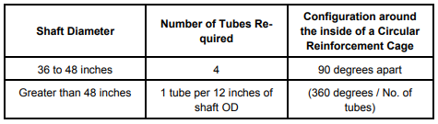
☐ Columns- BDM Section 20.3.2
  - Verify minimum diameter = 3’-0” - BDM Section 20.3.2.1 and BDM Section 20.3.3
  - Verify diameters larger than 5’-0” must be increased incrementally by 6”
  - When supported on drilled shafts, a minimum 3” from edge of shaft to edge of column shown -BDM Section 20.3.2.1
  - If column is less than 5’ long and supported on a drilled shaft verify option to extend shaft to the bottom of the cap - MEMO DM0111
  - Verify construction joint shown top and bottom for columns longer than 25’-0” - BDM Section 20.3.2.3
  - Verify bottom of a hammerhead cap at a minimum of 6 ft. above the finished ground line on stream crossings to prevent debris accumulation – BDM 30.3.4
☐ Columns/Drilled Shafts Longitudinal Reinforcement
  - Verify minimum bar size #8 (25M) longitudinal bars, with #10 (32M) bars being the preferred minimum - BDM Section 20.3.2.2
  - Verify there is no conflict between the column longitudinal bars and the cap bottom longitudinal bars
  - Verify maximum longitudinal steel spacing = 8” center to center- BDM Section 20.3.2.2
  - Verify select sections minimum and maximum reinforcement amount = 1% to 4% of gross area of concrete - SDS Section 8.4.3, 8.4.4.
  - The vertical column reinforcing bars fully developed where these bars enter the bent cap and the spread footing or pile cap - BDM Section 20.3.2.2 and SDS Section 8.4.6
  - Verify bar development length into cap or footing – the larger length required by MEMO DM0320 or
    - Single bar = 24 times bar diameter min. - SDS Section 8.4.6 Note: Reduction factor based on reinforcement area in excess of required can be used for strength development length calculation and still deemed “fully developed”
    - Double bar bundle = 28.8 times bar diameter - SDS Section 8.4.7
    - Triple bar bundle = 36 times bar diameter - SDS Section 8.4.7
  - Minimum development length into oversized drilled shaft = (Diameter column + development length) and (Diameter column + 2 times development length) for staggered bars - MEMO DM0115
  - Minimum clear distance between longitudinal bars is greatest of: (MEMO DM0107)
    - 5”
    - 5 times maximum aggregate size
    - 3 times the bar diameter
  - Verify staggered ultimate mechanical couplers for splicing longitudinal bars - SDS Section 8.4.5
    - 2’ stagger between adjacent splices - BDM Section 15.3.1.7.1 & Section 20.3.2.2.
  - Verify no splice zones dimensioned at maximum moment and/or interface
      - Typically, 1.5 times column diameter
  - Oblong cross sections columns with interlocking hoops center-to-center spacing not to exceed ¾ times the diameter of the cage. Overlaps interlocked by a minimum of four bars - BDM Figure 20.3-1 & BDM Section 20.3.2.2
  - Verify location of all construction joints at least 5 ft. above the water elevation expected during construction - MEMO DM0111
  - Verify all shafts detailed with construction casing unless approved otherwise by the RPG Engineer. The portion of the shaft below the bottom of the casing, whether in soil or rock, shall be detailed with a diameter that is six inches smaller than the diameter of the construction casing -MEMO DM0111
☐ Verify Columns/Drilled Shafts Transverse Reinforcement - SDS Figure 8.2/ SDS Figure 8.3, or MEMO DM0115
  - Minimum #6 (19M) transverse bars
  - Minimum clear distance between transverse bars is the greater of:
    - 5 times the maximum aggregate size
    - 5”
  - Verify note stating “Butt-welds of adjacent hoops shall be staggered around the perimeter of the column/shaft by a minimum distance of 1/3 of the hoop circumference - BDM Section 6.3.11.3.6
  - Verify selected max hoop spacing outside of “no splice” zones = 12” max. or 2 times spacing inside of no splice zones whichever is smaller - SDS Section 8.4.11 and SDS Section 8.4.12
  - Verify selected hoop spacing inside of “no splice” plastic hinge zones = smallest of 6” (8” for bundled hoops), 1/5 the least dimension of the column cross section, or 6 times bar diameter of longitudinal rebar - SDS Section 8.4.12, SDS Table 6.1
  - Reinforcement for column on a footing - SDS Figure 8.3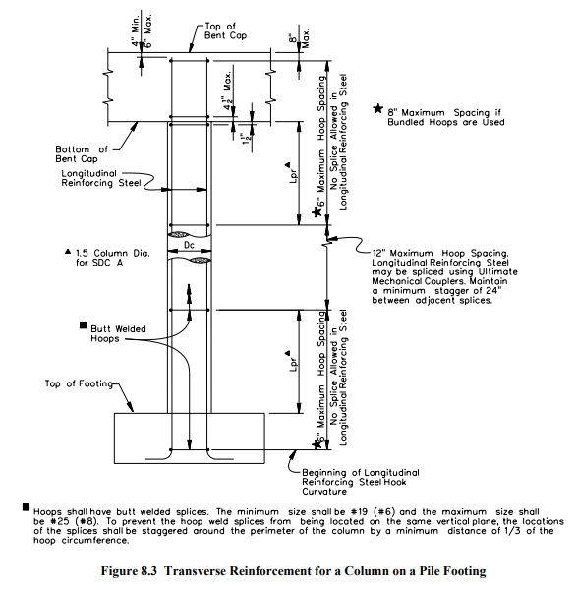
  - Reinforcement for column on a non-oversized drilled shaft - SDS Figure 8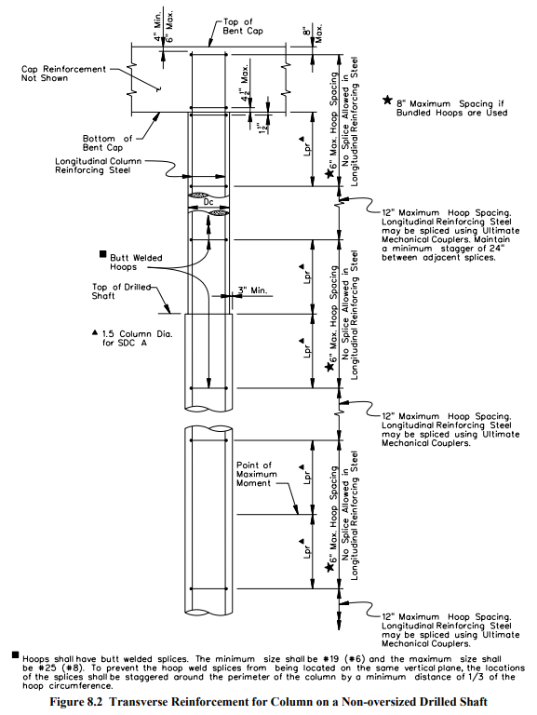.2

  - Reinforcement for column on oversized drilled shaft - MEMO DM0115
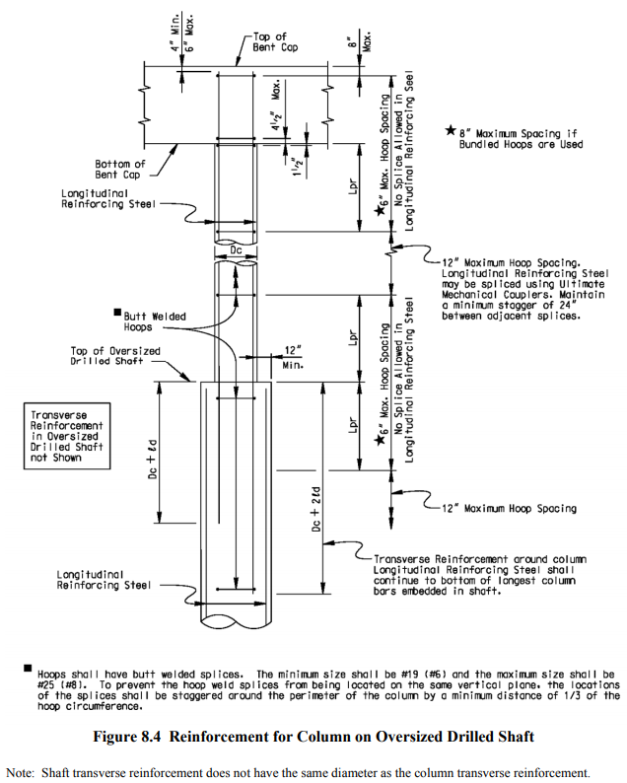
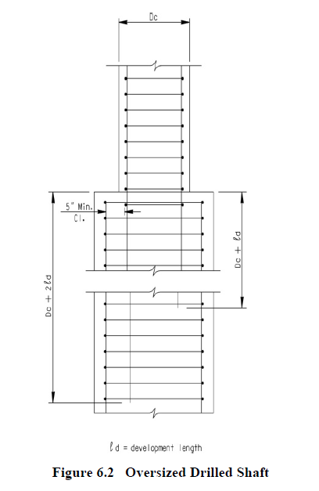
Spread Footings and Pile/Shaft Supported Footings BDM Section 19.5
☐ Verify if spread footings locations are at grade separations where suitable soils or rock are located at a relatively shallow depth (less than 10 ft.) Spread footings are prohibited at:
- stream crossings where they may be susceptible to scour,
- on fills, and
- beneath bents that are located within the reinforced soil mass associated with MSE walls
☐ Spread footing- settlement criteria is met per BDM Section 12.5.3.3 and consistent with FGER recommendations
☐ Verify minimum thickness of the footing:
- Spread Footings: 2′-6″
- Pile/Shaft-Supported Footings: 3′-6″
☐ Verify if shear reinforcement in footings is avoided (unless required due to seismic demand). If concrete shear governs the thickness of the footing is increased.
☐ For grade-separation projects, verify the footing is set at elevation to maintain a minimum of 2 ft. of backfill above the top of the footing. Consideration should also be given to future widenings.
☐ For “waterline” footings, verify the bottom of the footing elevation is set a minimum of
1 ft. below the mean low-water elevation
☐ In navigable waters, verify top of the footing is below a point to present a hazard to the waterway traffic or be set above water and be clearly visible to the waterway traffic
☐ Verify the required foundation geotechnical information is included on the plans -BDM Section 6.3 and BDM Fig. 6.3-7
☐ Top of Footing reinforcement: For pile/shaft-supported footings verify tension reinforcement is provided to anchor the piles in the top of the footing to resist the potential negative bending under seismic action
☐ Verify top of footing minimum reinforcement - #6 bars at 12 in o. c. each way
☐ Verify embedment Length of select bars: Vertical steel hooked on the bottom of footing and bar embedment lengths shown on the plans
☐ Verify select bar spacing: = 6 in on center min to 12 in on center max.
☐ Verify construction joints – not typical. Where used, footing construction joints should be offset 2 ft. from expansion joints or construction joints and constructed with 3-in deep keyways placed in the joint
☐ Verify adjacent stepped footings difference in elevation not less than 6 in. Extend lower footing at least 2 ft. under the adjacent footing
Prestressed Concrete Piles - BDWG 704-01 (piles w/o points), BDWG 704-02 (piles with points), BDM Section 6.3.12
☐ Verify concrete Class 5000 to 8000 - BDM Figure 15.2-1
☐ Verify pile data and strand data are specified on plans
☐ Pile embedment 1.3 pile width (DM 0312)

Superstructure Plan: BDM Section 6.3.13
☐ Verify overall span lengths match the Preliminary set of plans previously submitted - SCDOT BDM Figure 12.3-1
☐ Bar placement, orientation and splice lengths shown on plans- MEMO DM0320
☐ Verify select lap splices in compression members are sized for tension lap splices- MEMO DM0320
☐ If transverse reinforcing steel in a bridge deck is lapped near a longitudinal construction joint, verify the entire lap splice is placed on the side of the construction joint that will be poured last - BDM Section 15.3.1.7.1
☐ Verify select steel and concrete beam or girder spans anchored to the substructure on both ends with anchor bolts or dowels. Note that large diameter or high strength anchors are difficult to bend and alternative design will be required
☐ Superstructure side elevation view, verify if included, it may illustrate the type and size of steel girder or concrete beam used on the structure. Verify select reinforcing steel shown within the sidewalk and barrier parapet/ railing wall, spacing and locations for the placement of reinforcing bars. Bridge barrier maybe shown on this sheet or included as a separate detail sheet – BDM Section 6.3.14
☐ Verify bridge deck slab designed to extend 1½ in past the back face of the barrier parapet to accommodate slip forming. Deck revised to extend 1” for cored slab structures and 2” for bridges with sidewalks - BDM Section 17.3.7.3 and MEMO DM0119 and BDWG 705-01a-e.

Prestressed Concrete Girder – Continuous Span Superstructure: BDM Section 6.3.13
☐ Partial Plan/Plan View
  - Verify intermediate diaphragms placed per MEMO DM0311 and BDM Sections 15.5.7 and Section 17.3.6
  - Verify construction joints shown
  - Verify select reinforcement
    - Bar detailing – mark, size, type, spacing, count, and concrete cover
    - For skews up to 30 degrees, transverse bars are permitted to run parallel to skew - BDM Section 17.3.1
    - For skews above 30 degrees, transverse bars shall be placed perpendicular to longitudinal rebar - BDM Section 17.3.1
  - Miscellaneous information:
    - Skew angle
☐ Partial Side Elevation/ Side Elevation View
  - Verify intermediate diaphragms placed per DM0311 and BDM Sections 15.5.7 and 17.3.6
  - Verify location of the guardrail attachment shown
  - Concrete barrier drawn
    - Reference BDWG 705-01 for concrete barrier rebar marks, sizing, and spacing
    - Splice between horizontal bars noted and dimensioned - BDWG 705-01a
Structural Steel Girder – Continuous Span Structure: BDM Section 6.3.13
☐ Verify welded plate girders specified for bridge used with radius < 1200 feet - BDM Section 16.1.1.1
☐ Verify identical girders - BDM Section 12.2.5.4 & 16.1.2.1
☐ Verify minimum dimensions - BDM Section 16.5.2:
  - Plate girder flanges - BDM Section 16.1.2.3:
    - Minimum flange plate size = 12” x ¾”
    - Minimum flange thickness for curved girders = 1”
    - Maximum flange thickness = 3”
    - Flange widths in increments of 2”
    - Within a single field section, the width of each flange should be constant width
  - Plate girder webs BDM Section 16.1.2.6:
    - Minimum web thickness = ½”
    - Minimum change in web thickness at splices = 1/8”
  - Stiffener plates:
    - Minimum thickness = 3/8”
    - Longitudinal stiffened webs must end in zones of little or no applied tensile stresses - BDM Section 16.1.2.8
  - Connection plates:
    - Minimum thickness = ½”
  - Angles/Channels:
    - Minimum thickness = ¼”
☐ Verify shop splices shown- BDM Section 16.1.2.5:
  - Maximum two shop flange splices (three plate thicknesses) in top or bottom flange within a single field section
  - Flange shop splices located minimum 2 feet away from web splices
  - Flange and web shop splices located minimum 6” from transverse stiffeners
  - Flanges with different thicknesses spliced using 2.5:1 taper - BDM Figure 16.7-5
☐ Verify field splice lengths should not to exceed 120 ft. – BDM Section 16.1.2.4
☐ Verify flat bar transverse stiffeners proportioned in ¼” increments in width and 1/8” increments in thickness - BDM Section 16.1.2.7
☐ Verify select material - BDM Section 16.2.1
  - Grade 36, 50, 50W, HPS 70W, HPS 100W
  - Unpainted weathering steel - BDM Section 16.2.1.3:
    - Allowed for bridges over railroads and stream crossings that are not adjacent to highways
    - Prohibited:
      - In Beaufort, Berkeley, Charleston, Colleton, Dorchester, Georgetown, Horry, and Jasper counties
      - Over water crossings with < 10 feet of clearance
      - In industrial areas where there could be concentrated chemical fumes
      - Where abutments or retaining walls bound a depressed roadway
    - Bearing plates must match material of girders
    - Bolts, nuts, washers, and direct tension indicators are ASTMF3125(Grade A325), ASTM A563, and ASTM F959 Type 3
    - Provide at least two lines of bolts on each side of the web splice. See BDM 16.7.3
    - Paint limits - BDM Section 16.2.1.3.5 and Figure 16.2-1:
      - For semi-integral and integral end bents, girder must be painted a distance of 12” from the end wall at each end of bridge
      - For end bents with MSE walls, all superstructure steel must be painted 10 feet beyond the MSE wall
      - At joints, all superstructure steel must be painted within the greater of 10 feet of the joint or within 1.5 times the web depth
      - For interior bents supporting continuous spans, all superstructure steel must be painted 10 feet beyond each side of the centerline of bent
      - Paint system = NS2, Federal Shade # 30045 (brown)
  - High-strength bolts must be either - BDM Section 16.2.2:
    - Painted – ASTM F3125,Grade A325(Type 1) mechanically galvanized with galvanized DTI
    - Unpainted weathering – ASTM F3125,Grade A325 (Type 3) with weathering DTI
  - Grade 36 steel not used for secondary members when unpainted weathering steel is used in web and flanges - BDM Section 16.2.3
  - Steel for all splices must be same material as web and flanges of plate girders - BDM Section 16.2.3
☐ Verify transverse stiffeners on exterior girders should be placed on inside face of web - BDM Section 16.6.3.1
☐ Verify bearing stiffeners milled to bear on loaded flange and tight fit on unloaded flange - BDM Section 16.6.3.2
☐ Verify diaphragm/cross-framing placement - BDM Section 16.5.3.1:
  - Horizontally curved girders
    - Radially placed diaphragms (except end diaphragms)
    - End diaphragms placed parallel to centerline of bearings
  - Intermediate diaphragms/cross frames perpendicular to girders
  - Interior support and end diaphragms/cross frames placed parallel to centerline of bearings
Framing Plan BDM Section 6.3.14.2
☐ Verify placement of steel girders
  - Distances between bearing centerlines and the field splice shown
  - Distance between intermediate field splices shown,
  - Stiffener locations for steel girders shown
  - Distances between bearing centerlines and the diaphragm or cross frame
  - Distance between intermediate diaphragms or cross frames
  - Spacing of girder centerlines (radial/skewed and non-radial/skewed)
  - Chord Layout Sketch if roadway is on a curve
    - Long chord drawn
    - Work points at each bent labeled and dimensioned from long chord
  - Tie all dimensions to the construction, bearing, or bent centerlines
Prestressed Concrete Girder or Steel Girder Superstructure: BDM Section 6.3.14
☐ Typical Section
    - Minimum depth for single superstructure span is met per BDM Section 12.2.2.2 & 15.4.10 & AASHTO LRFD Table 2.5.2.6.3-1
    - Minimum number of girders per span = 4 - BDM Section 12.2.5.2
    - Maximum girder spacing = 10’-6” BDM Section 12.2.5.3
  - Deck
    - Minimum deck thickness = 8” - BDM Section 17.3.1
    - Minimum haunch/build-down = 0.5” - BDM Section 17.3.2.1 & BDM Figure 17.3-1
    - Reinforcing bar edge cover = 3”
    - Slab extension past back face of barrier to accommodate slip forming = 1.5” BDM Section 17.3.7.3
    - Verify use a corrosion protection system for bridge decks (galvanized rebar) on Interstate and other National Highway System routes located North of a line along SC Route 72 from the Georgia State line to Chester, SC and North of SC Route 9 from Chester, SC to Interstate Route I-77 and West of a line along Interstate Route I-77 from the intersection of SC Route 9 and I-77 to the North Carolina State line - BDM Section 15.3.1.5

  - Deck Overhang - BDM Section 12.2.5.5
    - ¾” drip groove located 2” from edge of deck BDM Section 17.3.7.3
  - Verify selected reinforcement size and spacing BDM Sections 17.3.1
    - Minimum vertical spacing between top and bottom reinforcing mats = 1.5”. Where conduits are present, increase 1½ in to accommodate conduit - BDM Section 15.3.1.3.3 and 17.3.1
    - Minimum horizontal spacing = 5.5”
    - Maximum transverse bar spacing = 9”
    - Minimum deck bar size = #5 (16M)
      - #4 (13M) bars may be bundled with primary bars at deck overhangs
      - #6 (19M) bars may be used if deck thickness exceeds 8.5”
    - Maximum bar length in the deck = 60 ft.; Galvanized reinforcing bars = 40 ft. For #3 (10M) or #4 (13M) bars =30ft.
☐ Verify selected typical concrete cover for top and bottom reinforcement– top bars = 2.5”, bottom bars = 1”, unless located low over a marsh - BDM Figure 15.3-2
☐ For prestressed girder bridges, verify that the stirrups extending from the beam will not interfere with the placement of the deck reinforcing
☐ For bridges on curves or large skews, verify no conflict between the longitudinal bars of the bent diaphragms and beam end U bars (need to stagger the diaphragm bars)
☐ Verify all girders within a span designed identically to the governing condition, either interior or exterior girder - BDM Section 12.2.5.4
☐ Stay-in-place forms not allowed in bays having longitudinal joints - BDM Section 17.3.3
☐ Rebar Schedule
☐ Quantities
  - Class 4000 concrete for deck - BDM Figure 15.2-1
☐ Deck Pouring Sequence - BDM Section 17.3.5.1 and BDM Figure 17.3-5 and notes below:
  - Required if deck volume > 300 yd³
  - Recommended if 225 yd³ > deck volume > 300 yd³
  - Pouring rates specified or referenced by 2007 Standard Specs - BDM Section 17.3.5
    - Maximum rate = 60 yd³/hr.
    - Minimum rate = 45 yd³/hr.
  - Positive moment regions in spans shall be poured first, and negative moment regions shall be poured last
  - For pours on a grade of 3% or greater, the pouring direction must be uphill
  - Note a minimum of 96 hours between pours or if previous pour is at 75% f’_{c} – MEMO DM0314
  - For integral end bents, the end wall concrete shall be cast concurrently with the deck pour of the end span - BDM Section 17.3.5.1
  - For continuous prestressed beam spans, closure diaphragms at the interior bents shall be cast concurrently with the deck slab above the support.
  - For expansion ends of continuous spans or simple span supports diaphragms may be cast prior to the placement of the deck slab - BDM Section 15.5.7
  - Construction Joints
    - Transverse construction joints must be placed parallel to transverse bars
    - Place transverse construction joints at end spans where uplift is a concern (end span = 60% or less of interior span) - BDM Section 17.3.5.2
    - For deck widths greater than 60 ft. the designer shall make provisions to permit placing the deck in practical widths due to screeding limitations - BDM Section 17.3.6
    - For decks wider than 90 feet, detail longitudinal open joint or closure pour
      - Minimum closure pour width = 3’-0”
      - Transverse bar lap splices located within closure pour
      - Not located in wheel path.
☐ End Diaphragms
☐ Interior Bent Diaphragms

Flat Slab Span Unit Superstructure: BDM Section 6.3.13
☐ BDWG Reference, not reflective of all span arrangements/configurations:
BDWG 702-05a | 30’ End Span Unit SS
BDWG 702-10a | 60’ End Span Unit SS
BDWG 702-12a | 74’ Span Unit SS
BDWG 702-15a | 90’ Span Unit SS
BDWG 702-16a | 100’ Span Unit SS
BDWG 702-20a | 4 Span 120’ Unit SS
BDWG 702-21a | 3 Span 120’ Unit SS
BDWG 702-25a | 150’ Span Unit SS & Details
☐ Plan
  - Verify maximum number of spans in one continuous unit = 4 - BDM Section 15.4.1.1
  - Verify skew angle of bridge CL
  - Verify bents, begin/end bridge, joints, etc. labeled
  - Verify slab, roadway, and barrier dimensions noted
  - Verify selected top and bottom transverse reinforcement detailed and dimensioned as such:
    - Top transverse –maximum #5 (16M) bars at 16” maximum spacing (or equivalent)
    - Bottom transverse –maximum #5 (16M) bars at 12” maximum spacing (or equivalent)
    - For skews up to 30 degrees, transverse bars permitted to run parallel to skew - BDM Section 15.4.12
    - For skews over 30 degrees, transverse bars shall be placed perpendicular to CL bridge - BDM Section 15.4.12
  - Verify selected top and bottom longitudinal reinforcement detailed and dimensioned -BDM 15.4.6
    - Refer to BDWG for representative bar sizing and spacing
    - Minimum bar spacing = 6 in o. c. in the deck
    - Minimum bar spacing = 4 in o. c. in edge beam
    - Non-continuous bars with stagger dimensions
    - Continuous bars with splice dimensions - MEMO DM0320
    - Verify selected longitudinal steel detailed in a two-bar alternating pattern, with one of the bars continuous through the slab. The maximum difference between the alternating reinforcing bars no more than two standard bar sizes - BDM Section 15.4.6
  - Longitudinal bars detailed alternating between continuous and non-continuous lengths, where the maximum difference between alternating bars is two bar sizes - BDM Section 15.4.6
  - For both end bents and interior bents non-integral bents shall not be used in conjunction with flat slabs - BDM Section 15.4.1.3
  - Staged Construction
    - Transverse bar splices dimensioned in the subsequent stage of construction per - BDM Section 15.4.3
☐ Side Elevation
  - Verify longitudinal bar splices noted and dimensioned - BDM Figure 15.3-6
  - Verify vertical bars spaced at 12” max
  - Verify constant slab thickness for multiple span flat slabs - BDM Section 15.4.1.2
☐ Camber for dead-load deflection shall be min. 1/8” in. for 22 ft., 3/16” for 30 ft. span and 3/8” in for 40 feet span - BDWG 700-04

☐ Verify notes shown
  - Concrete placement and pour rates
  - Drain details and locations
  - Bar bending details sheet
  - Splice lengths per - BDM Figure 15.3-6
    - Lap splices between two different sized bars are governed by the smaller bar per - BDM Section 15.3.1.7.2
☐ Quantities
  - Class 4000 concrete - BDM Figure 15.2-1
☐ Barrier Section
  - Conforms to - BDWG 705-01a-e and MEMO DM119. for MASH Barrier Parapet/Railing Wall
Prestressed Concrete Cored Slab Superstructure: BDM Section 6.3.13
☐ Verify not placed on any National Highway System route or route with an ADT ≥ 3000 VPD (present) - BDM Section 12.3.2.5
☐ BDWG Reference:
BDWG 704-30 | 30’-0” Cored Slab (3’-0” x 1’-9”)
BDWG 704-40 | 40’-0” Cored Slab (3’-0” x 1’-9”)
BDWG 704-50 | 50’-0” Cored Slab (3’-0” x 1’-9”)
BDWG 704-60 | 60’-0” Cored Slab (3’-0” x 2’-0”)
BDWG 704-70 | 70’-0” Cored Slab (3’-0” x 2’-0”)
☐ Minimum allowable width of cored slab bridges for common two-lane roadway sections on tangent alignment MEMO DM0120
Approach Roadway Width | Bridge Roadway Width | Bridge Width Out-to-Out | Cored Slab Units per Span | Approach Roadway  Lane Width | Approach Roadway Should.  Width | Bridge Shoulder Width
28'-0" | 27' -10" | 30"-0" | 10 | 10' -0" | 4'-0" | 3'-11"
34'-0" | 33'-10" | 36' -0" | 12 | 11'-0" | 6'-0" | 5'-11"
40' -0" | 39'-10" | 42' -0" | 14 | 12'-0'' | 8'-0" | 7'-11"
44' -0" | 45'-10" | 48'-0" | 16 | 12'-0" | 10'-0" | 10'-11"

☐ Verify maximum skew angle = 15 degrees BDM Section 12.3.2.5
☐ Verify not placed on skewed or chorded spans to create horizontal curves MEMO DM0120
☐ Verify prestressing stand size used - ½”, ½” Special, 0.6” or 9/16”
☐ Verify camber and deflection table listed for both cored slab units and solid units (without voids)
☐ Verify concrete Class 5000 to 10,000 - BDM Figure 15.2-1
☐ Debonding per - BDM Section 15.5.3.3

Prestressed Concrete Girder Details: SCDOT BDM Section 6.3.14.3
☐ BDWG references for various prestressed concrete beam types:
BDWG 704-07 | AASHTO Type I Modified Prestressed Concrete Beam
BDWG 704-08 | AASHTO Type II Modified Prestressed Concrete Beam
BDWG 704-09 | AASHTO Type III Modified Prestressed Concrete Beam
BDWG 704-10 | AASHTO Type IV Modified Prestressed Concrete Beam
BDWG 704-25 | 72” Bulb Tee Modified Prestressed Concrete Beam  (54” and 63” Beams are allowed)
☐ Verify prestressed concrete girder bridges designed as simply supported and continuous per MEMO DM0108
☐ Verify minimum web width = 7” (except for AASHTO Type II)
☐ Verify concrete Class 5000 to 10,000 - BDM Figure 15.2-1
☐ Verify standard strand size used - ½-in, ½-in Special, 9/16 in, or 0.6 in - BDM Section 15.3.2.1
☐ Verify concrete strength at release = 60% to 90% of f’c but not less than 4 ksi - BDM Section 15.5.3.2
☐ Verify minimum top flange reinforcement = # 4 bars at 24 in on center
☐ Beam camber and deflection:
- Verify that the algebraic sum of the beam camber at prestress transfer due to prestress force, the beam dead load deflections due to non-composite dead load, and superimposed dead load deflections due to applied superimposed dead loads results in a positive (upward) camber. Include dead load from future wearing surface in the determination of camber
☐ For skewed bridges, verify beam ends are square except for the top flange, which can be cast parallel to skew - BDM Section 15.5.11.2
☐ Verify no conflict between beam stirrup and diaphragm tension rod holes
☐ End Elevation – number of strands is within typical range
☐ Verify minimum strand spacing = 2” - BDM Section 15.3.2.2
☐ Verify draped strands - BDM Section 15.3.2.3.2
  - At ends of girders, minimum 4” between the top draped strands and straight strands located directly above
  - Max slope of strands = 9 degrees
  - Hold-down points located 5 feet on each side of the center of girder
  - Check potential location conflict between draped strands and diaphragm tension rod / insert holes
  - Verify draped strands do not conflict with any holes placed in girder web and have adequate clear cover
☐ Verify acceptable debonding - BDM Section 15.5.3.3
  - Maximum number of strands debonded = 25% of total strands
  - Maximum number of strands debonded in a row = 40% of total strands in row
  - Debonded strands are symmetrical about vertical axis of slab unit
  - Debonded strands not allowed in rows with 3 or less strands
  - Exterior strands must be fully bonded (including entire bottom row)
  - Maximum debonding length = 15% of entire beam length
  - Maximum number of debonded strands ending at any section = 40% of strands or 4 strands
  - Debonding sequence or debonding pattern
☐ Beams of the same size and similar length in the same bridge or within bridges should consider using the same number and pattern of strands (including height of draping) for these beams to facilitate fabrication

Superstructure Details - Structural Steel/ Girder Details: BDM Sections 6.3.14.4 and Sections 6.3.14.5
☐ Girder elevation view
- Verify span range 75’ – 300’ – BDM Section 12.3.2.3
  - Verify shear connector location, count, and spacing above the girder BDM Section 16.6.2
    - Shear stud size = 7/8” diameter by 5” length
      - 2” minimum penetration of stud into deck
    - Skew studs parallel to bottom deck rebar
  - Verify field splices detailed
  - Verify tension zone locations and distances
☐ Welded splices
- Weld types and sizes
- Absolute minimum weld size = ¼” - BDM Section 16.7.2.4
- Prohibited weld types - BDM Section 16.7.2.4:
        - Intersecting welds
        - Intermittent fillet welds (except for connecting stop bars at expansion joints)
        - Partial penetration groove welds (except for connecting tubular members in handrails)
- Verify test requirements listed
- Verify prohibited welding processes not used - BDM Section 16.7.2.1
- Electro-slag and electro-gas welding
- Gas metal arc and flux-cored arc welding require approval by SCDOT
- Verify permissible field welding locations - BDM Section 16.7.2.2
- Splices for piles
- Connecting pile tips to piles
- Connecting bearing plates to girders
- Connector plates between new and existing portions of widened bridges at ends of simply supported spans
  - Bolted splices
- Bolt hole locations - at least two lines of bolts on each side of web splice BDM Section 16.7.3.3
- Bolt hole diameter
- Bolt holes as filled
- Verify splice and fill plates and their sizes
- A note stating size and type of bolts BDM Section 16.7.1
- Type = ASTM 3125, Grade A325 (Type 3) for unpainted weathering steel
- Type = ASTM 3125,Grade A325 (Type 1) for painted steel
- Design = slip-critical at Service II limit state (except for secondary bracing members)
- Class B surface condition for slip-critical connections
  - Shear connector detail with location, edge distance, spacing, and size
Superstructure Details - Intermediate Diaphragms: BDM Section 16.5.3
☐ BDWG 704-05a and 704-05b used for Steel Intermediate Diaphragm Details
☐ BDWG 704-05c and 704-05d used for Steel Intermediate Diaphragm (Cross Frame) Details
☐ For skew = 0 or > 20 degrees, use BDWG 704-05b or 704-05d
- Diaphragms perpendicular to girder
☐ For 0 < skews ≤ 20 degrees, use BDWG 704-05a or 704-05c
- Diaphragms parallel to skew
☐ Verify concrete diaphragms for prestressed concrete girders with bottom flange below 20 MSL - MEMO DM0311
☐ Prestressed girder spans greater than 40 ft. long, verify intermediate diaphragms shown
☐ Spans with intermediate concrete diaphragms, the slabs to not be poured until a minimum concrete compressive strength of 3000 psi or seven days - BDM Section 15.5.7 and MEMO DM0311
☐ Verify two lines of intermediate diaphragms shown at third points if span is equal or greater than 100 ft.
☐ Minimum clearance between top of diaphragm and bottom of top flange for interior diaphragms for rolled beams = 3” - BDM Section 16.5.3.2
☐ For plate girders with web depth > 48”, verify use of cross frames - BDM Section 16.5.3.2
☐ Cross Frame Details - BDM Section 16.5.3.3:
    - K-frame cross frame used when girder spacing dictates that the diaphragm angle < 30 degrees
    - Cross frame transverse connection plates welded to both tension and compression flanges
    - Connection plate minimum width = 5”
Superstructure Details - Flat Slab Span Unit: BDM Section 6.3.13
☐ BDWG Reference:
BDWG 702-05b | 30’ End Span Unit SS Details
BDWG 702-10b | 60’ End Span Unit SS Details
BDWG 702-12b | 74’ Span Unit SS Details
BDWG 702-15b | 90’ Span Unit SS Details
BDWG 702-16b | 100’ Span Unit SS Details
BDWG 702-20b | 4 Span 120’ Unit SS Details
BDWG 702-21b | 3 Span 120’ Unit SS Details
BDWG 702-25b | 150’ Span Unit SS Details
☐ Section thru Span
  - Verify slab thickness
    - Check span-to-depth ratio per AASHTO LRFD Table 2.5.2.6.3-1
    - Top and bottom concrete clear cover per SCDOT BDM Figure 15.3-2
  - Verify top and bottom longitudinal and transverse reinforcement matches plan view
  - Shrinkage and temperature reinforcement - BDM Figure 15.4-1
    - For < 18” thick slabs, #5 (16M) at 18” spacing
    - For 18” to 28” thick slabs, #5 (16M) at 12” spacing
    - For > 28” thick slabs, LRFD Article 5.10.8.2
  - Verify barrier and Sidewalk location - BDM Section 17.6.1.5
    - V ≤ 45 mph – Concrete barrier is located on the outside edge of the sidewalk.
    - V ≥ 50 mph – Concrete barrier is located on the inside edge of the sidewalk. A pedestrian rail is located on the outside edge of the sidewalk
  - Verify Rebar Spacing - BDM Section 15.4.6
    - Minimum spacing in strip beams = 6”
    - Minimum spacing in edge beams = 4”
☐ Verify slab Build-down Details are consistent
☐ Wing Wall Section and Details are consistent
☐ Verify notes are shown:
  - Drain details per BDWG
  - Elastomeric bearing details per BDWG

Prestressed Concrete Cored Slab Details: BDM Section 6.3.13
☐ BDWG 704-29
  - Verify any inapplicable details or notes removed
☐ Verify notes
  - Specify strand diameter and corresponding tensioning load
  - Sheet reference to prestressed strand layout
☐

Camber/Blocking Diagram: BDM Section 6.3.14.6
☐ Verify table of camber information - List amount of deflection to the hundredth of an inch at the tenth points of each span and at field splice
  - Dead load weight of diaphragms and girders
  - Stay-in-place forms
  - Dead load of superstructure components
  - Superelevation
  - Correction for bridges on vertical curves
  - Total camber required
☐ Girder camber/blocking diagram
  - Location of the deflections for each tenth point of the span
  - Location of field splices
  - Vertical curve offset
☐ Camber note – “The information on the sheet is for use in the fabrication of the girder. The cambers shown are based on each girder deflecting independently and on all deck, concrete being place simultaneously. The contractor shall determine the screed grades required to achieve the proper finished grade, concrete depth, and reinforcing steel cover based on his/her equipment, procedures, and pouring sequence.”
Bearing Details BDM Section 6.3.14.7
☐ Verify selected side and end elevations for bearing assemblies
☐ Verify Elevation of Bearing Assemblies detailed and dimensioned– BDM Figure 21.2-5
☐ Verify bearing Plate Plan and Elevation provided along with - BDM Section 21.2.1.8
- Plate Width
- Plate Length
- Plate Thicknesses - 1 ½” minimum dimensioned at the center of the plate - DM 0220
- Plate Direction of Placement for Beveled Plates
- Beveled bearing plates for instantaneous slope at bottom of beam ≥ 1% - BDM Section 15.5.11.3
- For beveled bearing plates, minimum thickness at edge of plate = 1”
- Slotted holes at expansion bearings
- At integral bents, bearing plate plan dimensions = plain elastomeric pad plan dimensions – MEMO DM0212
- At non-integral bents, bearing plate is 1” wider than the elastomeric bearing -MEMO DM0212
- Minimum bearing plate/bolt edge distances -BDM Figure 21.2-3

Anchor Bolt Hole Diameter or Slot Width | Minimum Edge Distance from Centerline of Hole
1 ¼ in | 1 ½ in
1 ½ in | 2 in
☐ Verify booster Plates detailed and dimensioned
- Note booster plate could be incorporated into the bearing plate at no additional cost to the Department

☐ Verify Bearing Pad Plan and Elevation provided, detailed and dimensioned
- Pad min. edge distance = 3 in. from the edge of the build-up - BDM Section 21.2.4
- Rib Dimensions
- Grade and Durometer of Elastomer
- Method of Design (Method A or B)
- Bearing Design Load

☐ Verify elastomeric bearings detailed and dimensioned - BDM Section 21.2.1.6, 21.2.2, and 21.2.3
- Steel-reinforced elastomeric bearings for girder bridges
  - Holes prohibited
  - Minimum clearance between edge of elastomeric bearing and the edge of the bearing plate in the direction parallel to girder =1”- BDM Section 21.2.2.6
  - Minimum clearance between edge of elastomeric bearing and anchor bolt in direction perpendicular to girder = ½” - BDM Section 21.2.2.6
  - Minimum length or width = 6”
  - Minimum edge cover of steel shims = 1/8”
  - Plain elastomeric bearing pads shown for cored slab and flat slab bridges
  - At integral bents, use plain elastomeric pads – MEMO DM0212
    - Minimum thickness = ¼”
    - Plan dimensions of pad = plan dimensions of bearing plate
  - Minimum edge distance on beam seat = 3”
  - Shore A Durometer hardness of 50 or 60
  - Bearing Design Load Data
    - Elastomer Grade 2
    - Method A procedure of LRFD noted
    - Design loads listed
☐ Verify field weld detailed along each side of sole plate
☐ Field Weld Note: “Exercise caution where a field weld will be made while elastomeric bearing pad is in contact with metal. Keep the elastomer or elastomer band from being exposed to instantaneous temperatures greater than 400 degrees F or manufacturer’s recommended maximum temperature, whichever is less. Any damage to elastomeric bearing due to welding will be cause for rejection. Control temperature by use of heat crayons provided by the contractor.” - BDM Section 6.3.14.7
☐ Verify sole plate dimensions, studs location verified to clear conflict with the beam end region reinforcement and strands
☐ Verify fixed or Expansion Bearing Assemblies

Joint Details (Beam Supported Decks or Flat Slabs) BDM Section 6.3.14.9

Joint Type | Maximum Joint Opening | Usage | Reference
Compression Seal Expansion Joint (Elastomeric or Evazote Seal) | < or = to 3½ in | Preferred joint where skew ≤ 30° | BDM Section 21.1.1.5  BDWG 702-33
Strip Seal | 4 in | Where compression seals are not applicable | BDM Section 21.1.1.6  BDWG 723-01
Open Finger Plate, Modular Expansion, or other joint type | > 4 in | Where large movements are anticipated, and the drainage requirements of finger joints are undesirable | BDM Figure 21.1-1, BDM Section 21.1.1.7 & 21.1.1.8

☐ Verify applicable joint width and thermal movement information included - BDWG 702-33, 723-01 & 723-01a
☐ Verify sidewalk details applied, as applicable - BDWG 702-33, 723-01
- Cover plates required over expansion joints - BDM Section 21.1.1.11

Top of Slab Elevations (for Bridges with Transition Superelevation) BDM Section 6.3.14.10
Cross Section, Plan View Schematic, and Table are provided showing the following information:

☐ Verify a cross section of the bridge deck and top of slab elevations tables included. More than one sheet may be required
☐ Verify deck Elevations provided every 5 ft. or 10 ft. in equal station intervals – BDM Section 6.3.14.10
☐ Verify Deck Elevations at Beginning and End Bridge and CL Bents – BDM Section 6.3.14.10
☐ Verify Deck Elevations shown at – BDM Section 6.3.14.10
- Left Edge of Slab
- Left Gutter
- Finished Grade
- Longitudinal Construction Joints
- Right Gutter
- Right Edge of Slab
☐ All Elevations are displayed to three decimal places

Sidewalk and Railing Wall Details BDM Section 6.3.14.11
☐ Verify 42-in. MASH compliant concrete wall -MEMO DM0119 and BDWG 705-01a-e
Guardrail approach stiffness attachment to railing transition BDWG 705-01a-e
Minimum reinforcing steel placement – BDWG 705-01a-e
- maximum bar spacing = 12”
- bar spacing over 5 ft. at open joints and adjacent to transition = 5”
- maximum bar spacing near transition = 5”
- horizontal bars = (10) #5 (M16) (5 rows with 2 bars in each row)
☐ Verify barrier Parapet minimum height of above overlay is 36 in. (no bicycle pedestrian accommodations) – MEMO DM0119
☐ Verify barrier conduit details and notes added – BDWG 705-01c-d
☐ Verify appropriate fitting noted at each open joint – BDWG 705-01c-d
☐ Verify pull box details and notes added when barrier exceeds 300 ft. in length – BDWG 705-01c-d.

Approach Slab BDM Section 6.3.15
☐ Reference BDWG 702-30a, 702-30b, and 702-30.01 for approach slabs without sleeper slabs
☐ Verify approach slabs are provided when one of the following conditions exist – BDM Section 12.2.7
  - Bridge is located on US or SC route
  - Bridge is on Secondary Route where current traffic volume exceeds 400 vpd
  - Bridge has parallel wing walls
☐ Verify appropriate Approach Slab Sheets provided when Sleeper Slab is required – BDWG 702-32a-c.
☐ Verify approach slab thickness = 12 in. – BDM Section 17.4.2
☐ Verify minimum slab length = 20’-0”
☐ Verify minimum asphalt overlay provided when approach roadway pavement is asphalt =2” (when sleeper slab is not used) – BDWG 702-30a
☐ Verify minimum concrete cover = 3 in. bottom and min. cover = 2 in. top (increase top cover to 2 ½ in. when approach roadway pavement is concrete, or sleeper slab is used – for grooved surface finish) – BDM Section 17.4.2
☐ Verify distribution Steel = #5 (M16) spaced at 12 in. – BDWG 702-30a & 702-32a, BDM Section 17.4.2
☐ Verify top primary steel = #7 (M22) spaced at 12 in. – BDWG 702-30a & 702-32a, BDM Section 17.4.2
☐ Verify bottom primary steel = #9 (M29) spaced at 6 in. – BDWG 702-30a & 702-32a, BDM Section 17.4.2
☐ Where the project requires sidewalks on the bridge, verify the approach slab is widened to allow for the sidewalks
  - CHCU height are specified and do not conflict with the Bar Support Detail on the General Notes
☐ Quantities
  - Class 4000 concrete - BDM Figure 15.2-1

☐ All approach slabs shall be doweled to the end bent or pavement rest with #6 bars minimum at 12 in on center -DM 0220

Sleeper Slab BDM Section 12.2.8, MEMO DM0114
☐ Reference BDWG 702-30a, 702-30b, and 702-30c for approach slabs with sleeper slabs
☐ Verify requirements by MEMO DM0114 and following conditions:
  - Jointless bridge > 240 feet total length for steel girder bridges
  - Jointless bridge > 300 feet total length for prestressed concrete beam bridges
  - Distance from an integral or semi-integral end bent to nearest expansion joint > 240 feet for steel girder bridges
  - Distance from an integral or semi-integral end bent to nearest expansion joint > 300 feet for prestressed concrete beam bridges
  - An integral or semi-integral end bent is used and the end of the approach slab interfaces with a moment slab and railing
  - An integral or semi-integral end bent is used and the roadway pavement is constructed of concrete
☐ Verify sleeper slabs not used when staged construction is required or future widening expected – MEMO DM0114

Slope Protection Paving BDM Section 6.3.16, BDWG 804-01
☐ Verify clear plan view presented – BDM 6.3.16, BDWG 804-01
☐ Verify slope protection shown to extend beyond open drainage and closed drainage outfall locations - BDWG 804-01

Drainage Details (Closed Drainage) BDM Section 6.3.17
☐ No drains or discharge pipes shall be allowed inside of structural elements other than the bridge deck
☐ Verify the closed drainage system matches what is shown the roadway plans, mainly catch basin location, gradient, pipe diameters, downspouts, outfall location, cleanout
  - Minimum collector and downspout pipe diameter of 8 inches – BDM Section 18.3.2
  - Verify if scuppers with grates are provided if the bridge has a sidewalk BDM Section 18.2.5.1
  - Verify 6” min. diameter scuppers for inlets on all bridges - BDM Section 18.2.5.1
  - Fiberglass drains meeting requirements of ASTM D2996 and ASTM G154 – BDM 18.3.2, BDM 18.3.4
  - Cleanouts provided at key points – BDM Section 18.3.3.3
  - All metal components galvanized or stainless steel – BDM Section 18.1.2.3
☐ Collector pipes are not to extend below the bottom of the girders except for downspout locations
☐ Verify hanger anchor location verified to clear conflict with beam strand or reinforcement of concrete beams

Utility Details BDM 6.3.18 & BDM Section 17.6.5
☐ Verify utility lines not attached to the outside edge of the bridge where the structure crosses another highway or where aesthetics is a concern – UAM Section 6.9 (if allowed must be located between exterior beam and first interior beam)
☐ Utilities not permitted under the approach slabs – UAM Section 6.9
☐ Weight of the attachment does not exceed 110 pounds per foot – UAM Section 6.9
☐ Utility lines do not hang below the bottom of the beams or below the bottom of the deck on flat slab bridges UAM Section 6.9
☐ No field welding is allowed on steel beams – UAM Section 6.9
☐ No field drilling is allowed on concrete beams or steel beams – UAM Section 6.9
☐ For new construction, all attachments to concrete shall be made with threaded inserts that are cast into the concrete – UAM Section 6.9. Epoxy-resin anchors cannot be installed overhead or upwardly inclined - MEMO DM0408 Fig. 1.3
☐ Attachment hardware shall be galvanized or stainless steel

Existing Bridge Plans BDM Section 6.3.19
☐ Existing Bridge Plans included
☐ Note “For Information Only” included on each sheet
☐ New sheet numbers and Project ID added at tops of sheets

Bridge Widening BDM Chapter 23

☐ Verify the structural components of the existing structure, including splice locations, match - BDM Section 23.1.1
☐ Verify if the existing bearing function match with respect to fixity. The rotational and deflection
characteristics of the existing bearing type should be considered when new bearings selected - BDM Section 23.1.1
☐ Verify the need to seismically retrofit the existing bridge has been evaluated by the designer
☐ Verify the widened portion of the structure type and material are consistent with the existing structure, as practical. Materials used in the construction of the widening should have the same thermal and elastic properties as the existing structure. Avoid mixing concrete and steel beams in the same span. One exception to this is for an existing conventionally reinforced concrete T-beam structure. In this case, it is preferable to use prestressed concrete I-beams or steel rolled beams for the widened portion - BDM Section 21.1.3
☐ Verify the designer evaluated the need to rehabilitate or replace the existing bridge deck as part of the bridge widening project - BDM Section 23.1.4.1 & BDM Section 23.2
☐ As a general policy, no longitudinal expansion joints should be detailed, except for locations where concrete barrier rail or raised concrete median is placed on each side of the joint - BDM Section 23.1.4.2
☐ Verify a positive attachment of the widened and existing decks by lapping reinforcing steel. A positive attachment of the old and new decks should be shown for the entire length of the structure
☐ Verify the use of mechanical couplers or an epoxy-resin anchorage system instead of lapping reinforcing steel - BDM Section 23.1.4.3
☐ Verify that where existing deck will not be overlaid with concrete, the deck is to be removed to at least the existing gutter line - BDM Section 23.1.4.4
☐ Verify longitudinal construction joints are located over the beam flanges. Longitudinal construction joints to be preferably aligned with the permanent lane lines or located in the shoulder area of the deck - BDM Section 23.1.4.4.
☐ Removal of the deck past the outside beam line (i.e., to somewhere between the fascia girder and the first interior girder) will result in a temporary cantilever slab condition. Verify the designer checked and noted on plans that the temporary cantilever deck can resist the loadings anticipated during construction - BDM Section 23.1.4.4
☐ Verify a 1-in vertical saw cut shall be made in the existing slab where the slab is to be removed - BDM Section 23.1.4.4
☐ Verify closure pour located between the existing bridge and the widened portion. Where the deflection from the deck slab weight exceeds ½ in, a closure pour shall be used to complete the attachment to the existing structure. Closure pour is used with:
  - stay-in-place forms shall not be used under the closure pour
  - diaphragms between new and existing construction shall not be rigidly connected until after the new deck is poured, and
  - Reinforcing steel shall not be tied or coupled to the existing reinforcing steel until after the new deck is poured.
☐ Verify new interior bent substructure units required to support the bridge widening are not connected to the existing substructure. However, if the new substructure unit consists of one column, the new substructure shall be connected to the existing substructure, provided that suitable provisions are made in the design and details to prevent differential settlement - BDM Section 23.1.7
☐ Verify the spacing between the existing exterior girder and the adjacent new girder shall be equal to or less than the girder spacing of the existing span - BDM Section 23.1.8.
☐ Verify new diaphragm spacing for widenings shall be consistent with the existing diaphragm spacing - BDM Section 23.1.8.
☐ For bridge widening using a single girder system, verify a minimum of one interior diaphragm is shown - BDM Section 21.1.8
☐ Verify no field welding to the existing beams allowed. Exception is end diaphragm connections to existing beams at simply supported spans - BDM Section 23.1.8
☐ On the new deck, verify the same expansion joint type that used on the existing deck is detailed - BDM Section 23.1.8
☐ Verify existing horizontal and vertical clearances are maintained unless the existing clearance is greater than the minimum clearance required for a new structure - BDM Section 23.1.10

